NoSQL Project Report
Approach:
Two functions are to be implemented for Project 1.
- Find Business Based on City:
This function needs to identify the businesses that are in the specific city and store the results in a file in specific format. The first step here is to filter out the records from the collection based on the city. I used the filter function to extract the records and stored them in a list called businesses.
businesses = list(filter(lambda business: business['city'].decode() ==cityToSearch , data))

The Second step is to obtain the specific fields needed. Iterate the results in businesses list and obtain the data value for fields name, full address, city, and state of the businesses and store them in another list called interim result. Third step is to format the interim result with a delimiter “$” and write to file specified in the input.
Code :
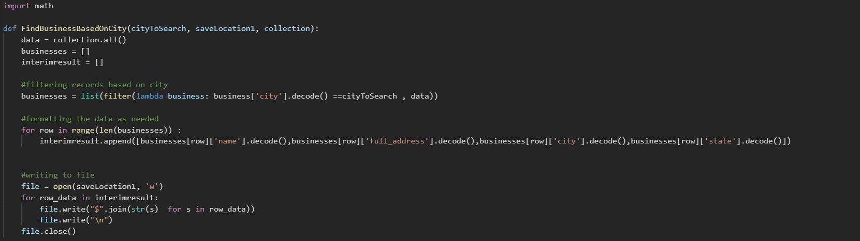
Once the function is implemented, I tested the function by calling the function with three input parameters. Using the additional test case file provided in the assignment, tested all possible scenarios and the results matched.
Output :
Test Case | Output | Passed/Failed
City - Tempe
City -Scottsdale
City - Mesa
Result Screenshot (when printed the result)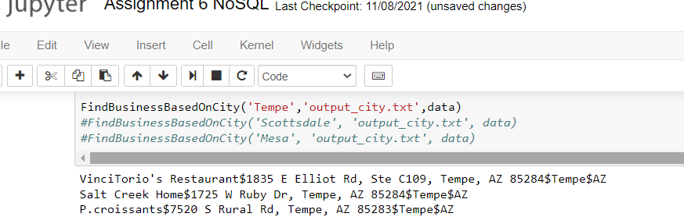
- Find Business Based on Location:

This function needs to identify all businesses near the specified location. Location is entered as latitude and longitude. First step here is collect all the records from the collection. Second step is to iterate the records in the collection to obtain the location information of each business and then calculated the distance between the inputted location and the specific business location (distance between point1 and point2). Distance can be calculated using the Haversine formula. Calculating Sin/Cos/Tan are built-in functions in Python which made the calculation much easier. Third step is to find the distance between the two points is within the maximum distance limit input. Fourth Step is to see whether the record matches two conditions.
Condition #1: Check distance calculated is less than or equal to maximum distance limit entered.
distance<=maxDistance

Condition #2: Check any/all of the categories of the business record matches the category/Categories specified in the input categories to search – If no item matches in both sets, then the category to search doesn’t exist in the record. If item(s) matches between the two sets, then the record matches the category To Search
not set(categories).isdisjoint(categoriesToSearch)

When both condition matches, then fetch the name of the business and write to an output file specified in the input.
Code : 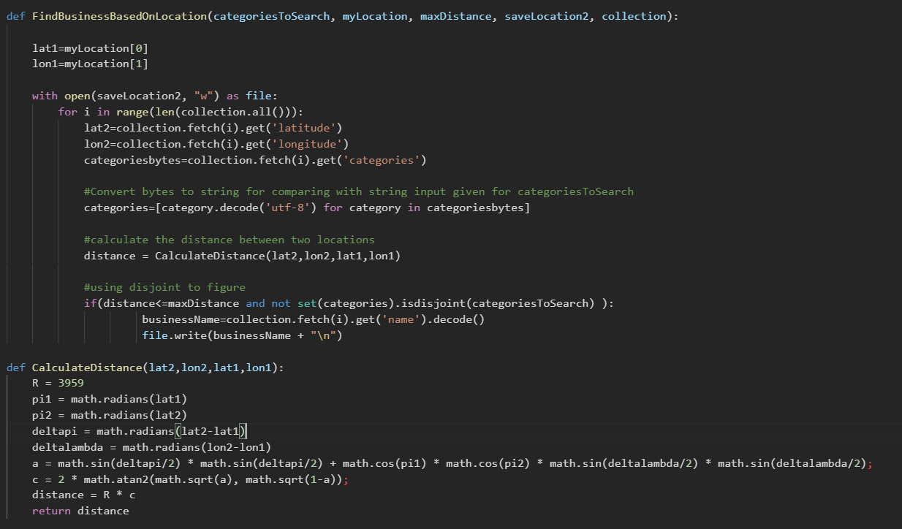

Output :
Test Case | Output | Passed/Failed
Category Gardeners, Max Distance - 20
Category – Food, Specialty Food, Max Distance -30
Category – Buffets, Max distance 15
Category – Restaurants,
Max distance – 10
Category – Bakeries, Max distance - 15

Result Screenshot (when printed the result):
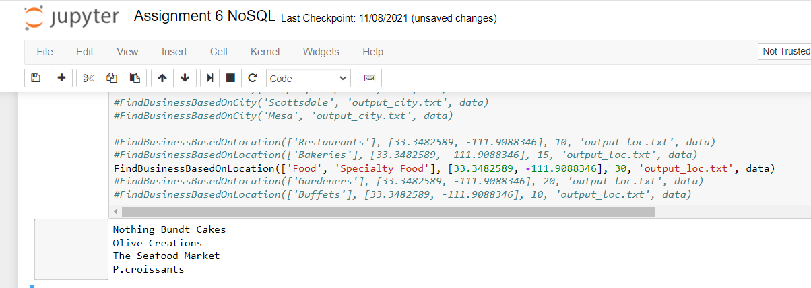
Lesson Learnt:
Despite learning mathematical formulas in school and universities, we haven’t used the real formulas as much at work or in day-to-day function. This assignment has given me a whole new way to write program using mathematical formulas. Always I have intended to write my own logic which is more methodical and has long lines of code. I originally wrote the second function by iterating the records and checking the categories from each record with category to search. When I tested multiple test cases, I realized the input categories to search is a list and it needs to be compared with another list and there are built-in functions to compare two sets and find common items in both sets. When writing SQL queries, these functions are common to use but not in programming languages like Java. Its more interesting to see how using mathematical functions simplifies our coding life and there is no doubt Python is used in data science. Also using the distance formula to find the distance between two points. Every day we use maps to find nearby locations in our mobile phones without knowing the secret behind, today I am very glad to understand and implement the functionality. I am confident and sure that my coding style will have a great impact after this assignment, and I am keen on using these techniques as much as possible.

